**QF600 (Asset Pricing) – Homework 6**

**Behavioral Finance**

Assume Barberis, Huang, and Santos economy where investor receives utility from consumption as well as recent financial gain or loss. Use these parameters:

Consumption growth has lognormal distribution:

where ε is standard normal random variable. Simulate probability distribution for consumption growth with (at least) 104 random draws from standard normal distribution.

With these parameters, risk-free rate is around 3% per year:

 Define x as one plus dividend yield for market portfolio:

and define error term:

where utility from recent financial gain or loss is given by:

Solve for e(x) = 0 to find equilibrium value of x, using bisection search:

1. Set x– = 1 and x+ = 1.1, and use simulated distribution of consumption growth to confirm that e(x–) < 0 and e(x+) > 0 ⇒ solution must lie between x– and x+
2. Set x0 = 0.5*(x– + x+) and use simulated distribution of consumption growth to calculate e(x0)
3. If |e(x0)| < 10–5, then you have converged to solution
4. Otherwise if e(x0) < 0, then solution lies between x0 and x+ ⇒ repeat from step 2 with x– = x0
5. Otherwise if e(x0) > 0, then solution lies between x– and x0 ⇒ repeat from step 2 with x+ = x0

Repeat for b0 in range from 0 to 10, in increments of 0.1 (or less).

1. Calculate price-dividend ratio for market portfolio:

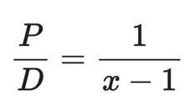

Plot price-dividend ratio (on vertical axis) vs b0.

**Answer:**  
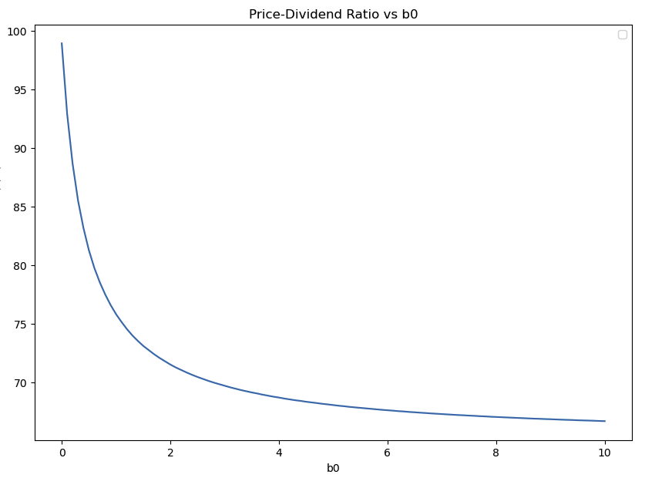

1. Calculate expected market return:

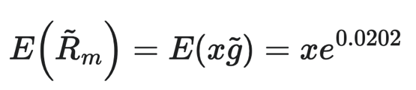

Plot equity premium (on vertical axis) vs b0.

**Answer:**

1. Briefly describe (in words, without using mathematical equations or formulas) main characteristics of v(∙) as well as economic significance and implications of b0 and λ.

**Answer:**

* *Main characteristics of utility function (v(.)):*

v(.) is the utility function that measures investors utility derived from the recent financial gains or losses. Utility function (v(.)) is a piecewise-linear function that is always increasing and asymmetrical. The steepness / gradient (l) of utility function is always greater than 1 during recent financial loss.This indicates loss aversion whereby investors are more sensitive to shortfall in financial gain (or outright financial loss) compared to financial gain (of the same magnitude). The recent financial gain or loss is measured relative to reference level based on risk-free rate.

* *Economic significance of b0:*

b0 >= 0 determines the extent to which utility from recent financial gain or loss contributes to investor’s lifetime utility. b0 can be seen as a scaler to allocate weight between the contribution of consumption (1st term) and recent financial gain or loss (2nd term). If b0 = 0, it means no utility is derived from recent financial gain or loss (no prospect theory, thus revert back to the standard power utility theory). The higher the b0 means the greater the weight/contribution of financial gain or loss to investors utility. In addition, the higher the b0, the price-to-dividend ratio will be lower (as plotted in question number 1), while the equity premium will be higher (as plotted in question number 2).

* *Economic significance of l:*

l represents the loss aversion coefficient in the utility function representing recent financial loss. The higher the l, the more sensitive investor to losses compared to gains and steeper slope in the utility function from financial loss, which leads to higher equity premium demanded by investors. Empirically, in real life, l is approximately 2, which means that investors are twice as sensitive for financial losses compared to financial gains. In addition, in the House Money Effect assumption, investor would become more loss averse with accumulated financial loss. l will increase by one for every 2% shortfall in value of the investment in stock (relative to appropriate reference level).